

**TRIBHUVAN UNIVERSITY**

**FACULTY OF HUMANITIES AND SOCIAL SCIENCE**

**A Project Proposal On**

**"NepQue: Coupon Platform in Nepal"**

**Submitted to**

**Department of Computer Application National College of Computer Studies**

In partial fulfillment of the requirements for Bachelor Degree in Computer Application

**Submitted By:**

**Bhabishya Bhatt**

**Samrat Acharya**

Table of Contents

1. Introduction 1
2. Problem Statement 1
3. Objectives 1
4. Methodology 2
   1. Requirement Identification 2
      1. Study of existing system 2
      2. Requirement Collection 3
   2. Feasibility Study 3
      1. Technical Feasibility 3
      2. Operational Feasibility 3
      3. Economic Feasibility 3
   3. High Level Diagram: 4
      1. Use-Case Diagram for User and Admin: 4
      2. Flow Chart for Admin: 5
5. Project Gantt chart 6
6. Expected Outcome 7
7. References: 7

# Introduction

Online shopping is increasing in Nepal, and the use of different digital wallets and other platforms is also increasing rapidly. Just a few years ago, there were only a few online platforms in Nepal, but today there are hundreds of them. Lots of shopping platforms, ride sharing platforms, online food ordering platforms, etc.

NepQue is an online coupon and deals sharing website that provides coupon codes that can be used on different platforms like Daraz, Sastodeal, Khalti, eSewa, etc.. NepQue collects coupon codes from via sources such as websites of these platforms, their social media handles and emails sent from these platforms.

# Problem Statement

People are missing out a lot of savings by not using free coupons provided by these platforms. Sometimes these platforms share the coupon via email, sometimes on their social media and sometimes via push notifications, and for a normal user it’s a lot of hassle to visit these media sites to find a simple coupon code.

# Objectives

The main objective of NepQue is:

* Offer users a streamlined platform for effortlessly discovering coupon codes applicable to any platform prior to making a purchase, thereby facilitating discounts and savings.

# Methodology

Prototyping models for system development life cycle will be used in this project. Since, this project contains requirements which might change or need frequent updates from time to time, so using a prototyping approach is the best approach for efficient flow of development of this project.

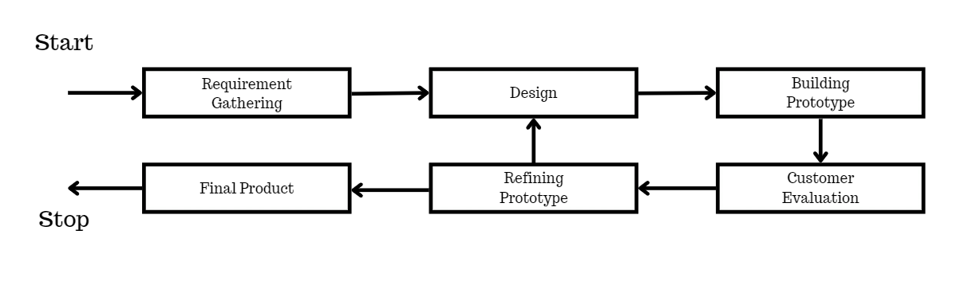

Fig: Prototyping model.

Prototyping is a type of model that heavily focuses on timely changing of user requirements. It creates quick prototypes of the system and waits for customer evaluation. If the customer is happy with the prototype, further development starts to take place.

## Requirement Identification

Requirement identification is the gathering of relevant requirements that will be used to develop a system. There are different methods to gather requirements which includes studying of existing systems, interviews, questionnaires etc.

### Study of existing system

Many coupon websites were visited for the purpose of system study. These websites include Rakuten.com, Fatcoupon.com, Topcashback.com etc. These websites provide immense features which can be both easy to use and learn. These websites allow users to search coupon codes for the website the user wants. These websites also allow users to create an account and subscribe and whenever a new coupon is published of their favorite store/website they get email notifications.

### Requirement Collection

Requirements will be collected through interviews, Google searches, website visits and friendly suggestions.

* + - 1. **Functional Requirements**

Anyone can create an account and login into the system. Admin can add or delete the coupons. Users can view the coupon codes without creating an account. Users need to create an account and login to submit the coupon codes.

* + - 1. **Non-Functional Requirements**

NepQue will provide users a platform they can visit without having to create an account.

## Feasibility Study

It is the study of how well the system will function under the given constraints. It studies how easy it is to build a system under given constraints. The constraints include operational feasibility, economic feasibility, and technical feasibility.

### Technical Feasibility

This system meets the technical feasibility as it will be using existing technologies like HTML, CSS, JavaScript, PHP and MYSQL etc. as well as simple hardware specifications.

### Operational Feasibility

Since the system promises to provide easier and understandable user interface as well as responsiveness when used in another device. Thus, the proposed system will be operationally feasible.

### Economic Feasibility

The system will be feasible economically as it is small scaled.

## High Level Diagram:

This shows the high level or abstract design of how the system will behave and how the users can interact with it.

### Use-Case Diagram for User and Admin:

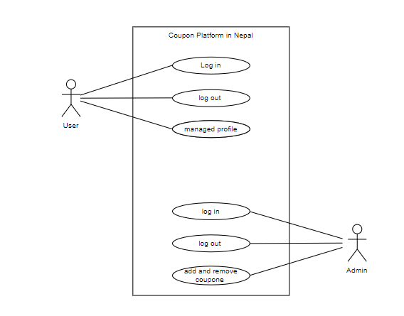

**Fig: Use case diagram of NepQue.**

### Flow Chart for Admin:

Start

Admin Home Page

Stop

Insert, update ,remove

Valid

Yes

No

Admin Authentication

Invalid

Insert Username and Password

**Fig: Flow Chart for Admin**

# Project Gantt chart

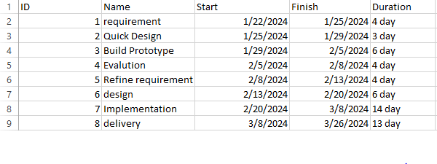

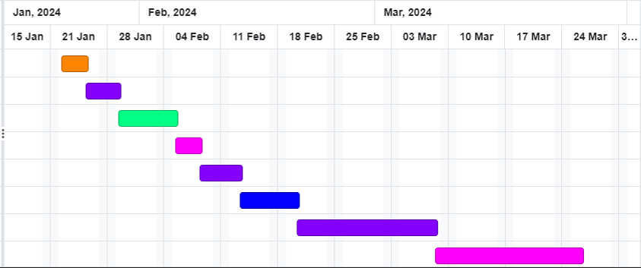

**Fig: Gantt chart**

# Expected Outcome

This project is expected to deliver a high performance website with attractive and easy to use UI. This project will meet all of its objectives as well as address all the shortcomings to create the first Coupon site in Nepal.

# References:

1. [https://www.rakuten.com.](https://www.rakuten.com/)
2. [https://fatcoupon.com.](https://fatcoupon.com/)
3. <https://blog.shift4shop.com/creating-a-coupon-website>
4. [www.google.com.np](http://www.google.com.np)
5. <https://nichehacks.com/how-to-create-own-coupon-site-y5y7r1/>